Executes the Ansible – playbooks code

1.Go to Ansible Controller

Cmd: cd/etc/ansible



2.Go to /etc/ansible directory



3.Create a playbook and add host details,become, become_user details

Cmd: vim playbook.yml

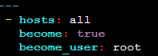

4.Add a task to install multiple packages



5.Use loop to install multiple packages like nginx,git,tree

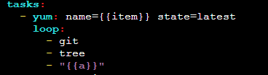

6.Add a task to start nginx service



7.Write variables to pass package name to both the tasks mentioned above



8.Validate the ansible-playbookcode

Cmd: ansible-playbook a.yml –syntax-check



9.Execute the ansible code

Cmd: ansible playbook a.yml

